**Wind Turbine Logic Game (solution)**

Professor Max Powers has decided to build a wind turbine but doesn’t know

what style would be best. He enlists the help of 4 students. Each student

comes up with a different blade shape and number of blades. They brought

him their designs, but he has dropped the folder and needs your help piecing

it back together. Use the clues below to match the student, blade number,

and blade shape.

Clue 1: Either Ariel or the turbine with 4 blades has blade shape B

Clue 2: Wendy designed blade shape A

Clue 3: Wattson’s design, the design with 4 blades, and blade shape D are 3 different designs.

Clue 4: Of the designs with 4 blades and design B, one is Ariel’s and the other is Wendy’s.

Clue 5: Wattson’s design has 2 more blades than Ariel’s design.

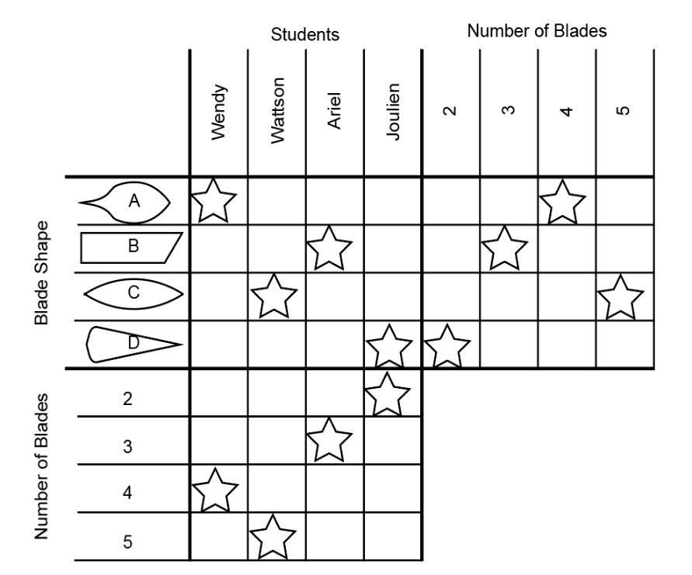

Hint: place an X in any box that cannot be true and a star in any box that must be

true. Anytime a star is placed, X’s can be placed in all other boxes in that column

and row.

Example 1: when a star is placed based on the clues, X’s can be placed in all the

other boxes in the row and column



Example 2: Completed puzzles should look like this.

