5x5 Game (solution)

Start from the top and choose one letter from each successive row to form
five 5-letter words associated with visible energy. You may jump to any
column as you go down. There is never a need to rearrange the letters,
and every letter will be used exactly once. What are the five words?
LIGHT; LUMEN; LAMPS; GLARE; BULBS

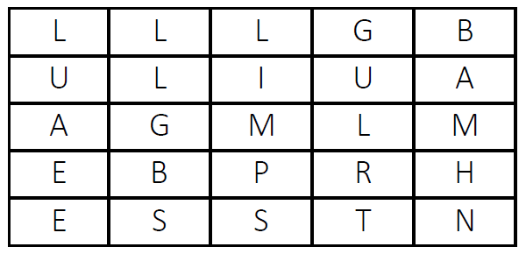
Start from the top and choose one letter from each successive row to form
five 5-letter words associated with power. You may jump to any column as
you go down. There is never a need to rearrange the letters, and every
letter will be used exactly once. What are the five words?
HYDRO; STEAM; JOULE; WATTS; MOTOR

