**🌀 Build-a-Turbine Relay: Lesson Plan (Grades 6–8)**

**Overview**

Students compete in teams to complete turbine engineering challenges. Each challenge reinforces concepts of design, energy transfer, and efficiency. At the end, they assemble and label a turbine drawing, then justify their design choices.

**NGSS Standards**

* **MS-PS3-3**: Apply scientific principles to design, construct, and test a device that either minimizes or maximizes thermal energy transfer.
* **MS-ETS1-1**: Define the criteria and constraints of a design problem with sufficient precision to ensure a successful solution.
* **MS-ETS1-2**: Evaluate competing design solutions using a systematic process to determine how well they meet the criteria and constraints.

**Disciplinary Core Ideas (DCI)**

* **PS3.B: Conservation of Energy and Energy Transfer** – When kinetic energy of wind changes, energy is transferred to blades and generator.
* **ETS1.A: Defining and Delimiting Engineering Problems** – Criteria and constraints guide turbine design (e.g., cost, efficiency, materials).
* **ETS1.B: Developing Possible Solutions** – Multiple solutions compared and tested for stability, efficiency, and safety.
* **ETS1.C: Optimizing the Design Solution** – Data analysis used to improve turbine designs.

**Science & Engineering Practices (SEP)**

* **Asking Questions and Defining Problems** – Identify trade-offs in tower height, blade angle, or material choice.
* **Developing and Using Models** – Turbine diagram acts as a model showing energy flow.
* **Analyzing and Interpreting Data** – Calculate RPM, scale measurements, and efficiency trade-offs.
* **Using Mathematics and Computational Thinking** – Work with ratios (scale model to real turbine) and RPM calculations.
* **Engaging in Argument from Evidence** – Justify design choices (e.g., stability vs. efficiency).
* **Constructing Explanations and Designing Solutions** – Apply scientific principles to propose improved designs.

**Crosscutting Concepts (CCC)**

* **Energy and Matter** – Energy flows through the turbine system and changes forms (wind → mechanical → electrical).
* **Cause and Effect** – Blade shape/angle affects spin speed and efficiency.
* **Systems and System Models** – Turbine represented as a model of interconnected subsystems.
* **Structure and Function** – Part designs (blades, nacelle, tower) influence performance.
* **Stability and Change** – Stable base allows change (motion of blades) without collapse.

**Learning Goals**

* Analyze how turbines convert kinetic energy into electrical energy.
* Apply math to calculate speed (RPM) and scale distances.
* Evaluate design trade-offs for turbine stability, efficiency, and material choice.
* Strengthen collaboration, critical thinking, and scientific communication.

**Time Length**

* 40 minutes-45 minutes

**Materials**

**📋 Prep Beforehand**

**Materials:**

* **6 stations signs**: Base, Tower, Nacelle, Blades, Rotor, Final Station
* **Challenge cards** (details below)
* **Turbine part cards or cutouts** (for each team) 5 total of each and bonus card
* **Clipboards, paper, and pencils** for group sheet
* **6 station baskets**
* **1 cones or markers**
* **Legos or Knex and paper towel rolls**
* **Stopwatches**
* **2 Calculators**
* **5 Post It Poster Papers**
* **Markers**
* **Turbine parts with definitions**
* **Measuring Wheel**
* **Key for any Adults present**
* **5 Clothes pins or clips**
* **Group Worksheet (enough for 5 groups)**
* **Group Puzzle sheet (enough for 5 groups)**

**Teams:** Divide students into teams of 4–6 (depending on your group size).  
**Set-up:** Place each station a good distance apart (30–50 feet) to promote movement.

**Procedure (40 minutes)**

1. **Introduction (5 min)**
   * Discuss turbines in real-world energy systems.
   * Present challenge criteria: efficiency, stability, design trade-offs.
2. **Relay Challenge (25 min)**
   * 5 stations with deeper-level tasks:
     + **Base**: Build for stability *and explain trade-offs if taller vs shorter*.
     + **Tower**: Convert scale measurements into proportional real-world values.
     + **Nacelle**: Analyze parts/functions and propose improvements.
     + **Blades**: Calculate RPM and discuss impact of blade length/angle.
     + **Rotor**: Use word puzzle then write a short paragraph (with vocab) describing energy transfer.
3. **Final Destination (10 min)**
   * Teams assemble turbine drawings.
   * Add **one design improvement** or bonus feature with justification.
   * Share quick presentations with peers.

**Differentiation for 6–8**

* Require multi-step calculations at Tower & Blades stations.
* Longer written reflections (paragraph form).
* Encourage evidence-based reasoning for design improvements.

**Assessment**

* Completed turbine drawing with labeled parts & justification.
* Group worksheet with calculations and reflections.
* Short team presentation (peer + teacher assessed).

**📏 BASE Station — Balance & Stability Challenge**

🎯 **Goal:** Engineer a stable base strong enough to support a paper towel roll in the wind.

🛠️ **What to Do:**  
• Use the tray materials to design and build a base.  
• Structure must be off the ground, stable enough to hold a paper towel roll upright, **and withstand at least 3 “wind gusts” (fan or breath) without tipping.**  
• Record: What design choices helped your base stay stable?

💬 **Discuss & Write:**  
Why is a strong foundation critical for wind turbines in real-world environments (think soil, concrete, vibration)? Write at least **two sentences** on your group sheet.

✅ **To Earn Your BASE Card:**  
• Demonstrate your base & show your written reasoning.  
• Deconstruct your design and return all materials.  
• Collect your **BASE Card** → Move to Station #2!

🌀 **Tip:** Engineers test with real wind tunnels—your breath is a mini wind tunnel!

**📏 TOWER Station — Scaling Up with Math**

🎯 **Goal:** Model a turbine’s tower height and apply proportional reasoning.

🛠️ **What to Do:**  
• A real turbine is 80 meters tall. Using the measuring wheel, mark out **8 meters (1/10 scale)** and drop your cone.  
• Solve:

1. If your stride = 0.8 m, how many steps would it take to walk the tower height?
2. A turbine blade is 40 meters long. How long would that blade be at 1/10 scale?

✏️ Write both answers on your sheet.

✅ **To Earn Your TOWER Card:**  
• Show your cone placement and math solutions.  
• Put away tools neatly.  
• Collect your **TOWER Card** → Move to Station #3!

🌀 **Tip:** Scale models are how engineers test massive structures safely!

**⚙️ NACELLE Station — Systems at Work**

🎯 **Goal:** Connect turbine components to their functions and analyze the nacelle.

🛠️ **What to Do:**  
• Match turbine parts with their functions using the cards.  
• Write **a detailed function statement** for the nacelle that includes: generator, gearbox, and control systems.

✅ **To Earn Your NACELLE Card:**  
• Show your matches & nacelle explanation to an adult.  
• Return all items neatly.  
• Collect your **NACELLE Card** → Move to Station #4!

🌀 **Tip:** The nacelle isn’t just the “brain”—it’s also the powerhouse that converts motion to electricity!

**💨 BLADES Station — Data in Motion**

🎯 **Goal:** Measure and calculate turbine blade RPM with accuracy.

🛠️ **What to Do:**  
• One teammate = the blade. Spin with arms out at a steady speed.  
• Others count revolutions for **15 seconds** with a stopwatch.  
• Calculate **RPM = (Revolutions ÷ Seconds) × 60.**  
• Bonus Q: Why do blades have to slow down in strong winds (think safety + efficiency)?

✏️ Record your RPM & bonus answer.

✅ **To Earn Your BLADES Card:**  
• Show RPM calculation and bonus reasoning.  
• Reset the station.  
• Collect your **BLADES Card** (+ Bonus Card if earned!) → Move to Station #5!

🌀 **Tip:** Engineers balance speed for maximum power output without risking damage.

**🧩 ROTOR Station — Energy in Action**

🎯 **Goal:** Learn and explain how the rotor captures wind energy.

📝 **What to Do:**

1. Complete the laminated word search.
2. Write **two sentences** using at least 4 words from the puzzle to explain the rotor’s role in energy conversion.
3. Early finishers: Act out rotor motion—include **rotation, torque, AND connection to the shaft.**

✅ **To Earn Your ROTOR Card:**  
• Get puzzle + explanation checked.  
• Earn a **Bonus Card** if your team demonstrates the rotor motion with correct engineering terms.  
• Erase puzzle sheet & reset.  
• Collect your **ROTOR Card** → Return to Station #1!

🌀 **Tip:** The rotor captures *kinetic energy* from the wind and transfers it into *mechanical energy.*

**🏁 Final Destination Station — Design Challenge**

🎯 **Goal:** Apply your learning to design a complete turbine.

🖍️ **What to Do:**  
• On large Post-It, **draw and label your turbine** using the cards you’ve collected:  
✅ BASE  
✅ TOWER  
✅ NACELLE  
✅ BLADES  
✅ ROTOR  
• Use Bonus Cards for creative add-ons (bird-safe blades, sensors, lightning protection, etc.).  
• Write **a 2–3 sentence explanation** of how your turbine design would perform in Kansas winds.

✨ Don’t forget:  
• Label every part clearly  
• Give your turbine a creative name  
• Add color + creativity

See 6-8 worksheet found in the folder

**Teacher Key with Sample Answers (Grades 6–8)**

**Station 1 – BASE Station: Balance & Stability**

**Q:** Why is a strong foundation critical for real-world wind turbines?

**Look for:**

stability, weight distribution, vibration control, weather resistance.

**Sample Answer:**

*The base keeps the turbine from tipping over in strong winds. It spreads the weight across the ground and reduces vibration so the tower and blades don’t get damaged.***Station 2 – TOWER Station: Scaling with Math**

1. **If your stride is 0.8 meters, how many steps to walk an 80-meter tower?**  
   **Correct Work:** 80 ÷ 0.8 = 100  
   **Sample Answer:**

*It would take me 100 steps to walk the height of the tower.*

1. **A turbine blade is 40 meters long. At 1/10 scale, how long is the blade?**  
   **Correct Work:** 40 ÷ 10 = 4  
     
   **Sample Answer:**

*At 1/10 scale, the blade would be 4 meters long.* **Station 3 – NACELLE Station: Systems at Work**

**Q:** Write a detailed function statement for the nacelle (include generator, gearbox, and control systems).

|  |  |
| --- | --- |
| BLADES | Long arms that catch wind and begin the turbine's  rotation. |
| ROTOR | Spins with the blades and connects to the shaft to  power the turbine. |
| NACELLE | The housing that holds the gearbox, generator, and  control system. |
| GENERATOR | Converts the spinning motion into electrical energy. |
| BASE | Heavy foundation that keeps the turbine stable and  upright. |
| TOWER | Tall support that lifts the blades higher into  stronger wind. |

**Look for:** All 3 parts mentioned with clear function.

**Sample Answer:**

*The nacelle is the powerhouse of the turbine. Inside, the* ***gearbox*** *increases the shaft speed, the* ***generator*** *changes the motion into electricity, and the* ***control systems*** *make sure the turbine is running safely and shuts it down if winds are too strong* **Station 4 – BLADES Station: Data in Motion**

1. **Revolutions in 15 seconds:** *Student measured (example: 12)*
2. **Formula:** RPM = (Revolutions ÷ Seconds) × 60  
   Example with 12 revolutions:  
   *12÷15=0.8 rev/sec → 0.8 x 60 = 48 RPM*

**Sample Answer:**

Our blades spun 12 times in 15 seconds. That equals 48 RPM.

**Bonus Question:** Why do blades have to slow down in strong winds?

**Look for:** safety, efficiency, damage prevention.

**Sample Answer:**

*Blades slow down in strong winds so they don’t break or overheat the system. It helps protect the turbine and keeps power levels steady.* **Station 5 – ROTOR Station: Energy in Action**

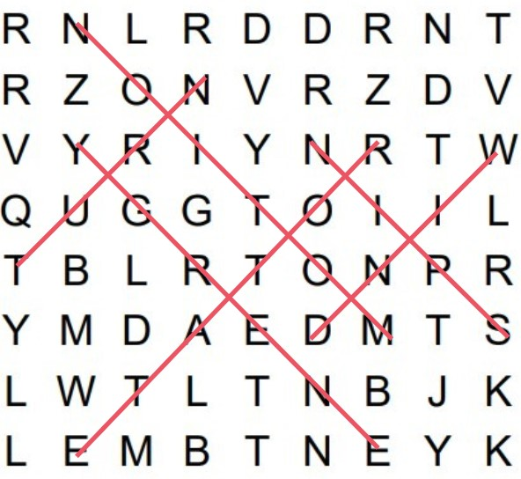

**Q:** Write 2 sentences explaining the rotor’s role in energy conversion (use at least 4 vocab words from the puzzle).

**Look for:** kinetic → mechanical energy, mention shaft, wind, motion, rotation, torque, etc.

**Sample Answer (with underlined words):**

*The* ***rotor*** *captures* ***wind*** *and turns it into* ***motion****. This rotation creates* ***torque*** *that spins the* ***shaft*** *to start making energy.* **Final Check**

* **All 5 cards earned:** Each station completed with acceptable answers.
* **Bonus card earned:** Either correct Rotor motion demo or strong answer at Blades Station.
* **Final Destination Build:**
  + *All 5 parts drawn and labeled.*
  + *Creative turbine name.*
  + *Color and detail.*
  + *Explanation of performance in Kansas winds.*

**Sample Answer for Build Explanation:**

*Our turbine ‘Kansas Twister’ has a wide base and tall tower. It would work well in Kansas because it is built to handle strong winds and still generate electricity safely.*

**Cards and Station Labels**

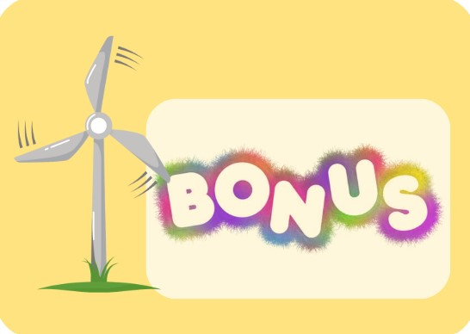



­­­

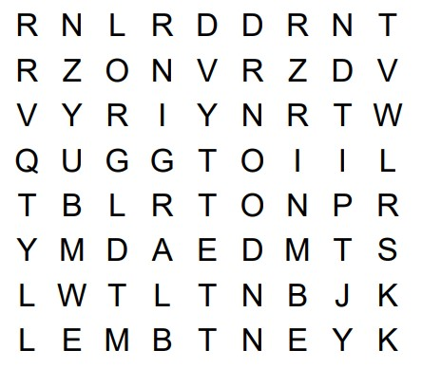Rotor Word Search

Spin Turn Rotate

Motion Energy Wind

