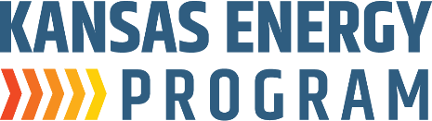
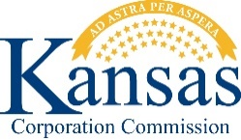

Hosted by K-State Engineering Extension’s Kansas Energy Program in partnership with the Kansas Corporation Commission:

KidWind Challenge Workshop

Organizers/Speakers from the Kansas Energy Program:
- David Carter
- Kurt Foley
- Ryan Hamel
- Mandy Putnam
- Stacy Harris

When and Where (choose 1):
- Northcentral Regional Workshop (Manhattan) Oct. 13, 2025 (Mon) – 9:30am-3:30pm [6 hours] Cost: Free
Manhattan Public Library, Groesbeck Room
629 Poyntz Ave, Manhattan KS 66502

- Northeast Regional Workshop (Kansas City, KS)
Oct. 16, 2025 (Thu) – 9:00am-3:30pm [6 hours] Cost: Free
Kansas City Kansas Community College, Technical Education Center M118
6565 State Ave, Kansas City, KS 66102

- Southwest Regional Workshop (Dodge City)
Oct. 28, 2025 (Tue) – 9:00am-3:30pm [6 hours] Cost: Free
Dodge City Public Schools USD 443, Conference Room 159-160
2112 First Avenue, Dodge City KS 67801

Continuing Professional Competency Activity Attendance Verification

The workshop presented as part of the STEM-focused Kansas KidWind Challenge is intended to provide the number of contact hours shown above and the opportunity for you to earn the equivalent number of Professional Development credit hours. This workshop is focused on wind energy. It is your responsibility to certify the time you actually spent in attendance and the applicability of the content to your field of practice.

I certify that I spent hours in attendance of the above program, and I further certify that the material presented assisted me in maintaining, improving, or expanding the skills and knowledge related to my field of practice.

Participant Name: ___________________________________________________________ ^{(Print)}
__________________________________________________________________________
^{(Signature)}

Attendance verified by:_________________________________________________________ ^{(Signature)}f

