🌀 Build-a-Turbine Relay: Lesson Plan (Grades 6–8)

Overview
Students compete in teams to complete turbine engineering challenges. Each challenge reinforces concepts of design, energy transfer, and efficiency. At the end, they assemble and label a turbine drawing, then justify their design choices.

NGSS Standards
- MS-PS3-3: Apply scientific principles to design, construct, and test a device that either minimizes or maximizes thermal energy transfer.
- MS-ETS1-1: Define the criteria and constraints of a design problem with sufficient precision to ensure a successful solution.
- MS-ETS1-2: Evaluate competing design solutions using a systematic process to determine how well they meet the criteria and constraints.

Disciplinary Core Ideas (DCI)
- PS3.B: Conservation of Energy and Energy Transfer – When kinetic energy of wind changes, energy is transferred to blades and generator.
- ETS1.A: Defining and Delimiting Engineering Problems – Criteria and constraints guide turbine design (e.g., cost, efficiency, materials).
- ETS1.B: Developing Possible Solutions – Multiple solutions compared and tested for stability, efficiency, and safety.
- ETS1.C: Optimizing the Design Solution – Data analysis used to improve turbine designs.

Science & Engineering Practices (SEP)
- Asking Questions and Defining Problems – Identify trade-offs in tower height, blade angle, or material choice.
- Developing and Using Models – Turbine diagram acts as a model showing energy flow.
- Analyzing and Interpreting Data – Calculate RPM, scale measurements, and efficiency trade-offs.
- Using Mathematics and Computational Thinking – Work with ratios (scale model to real turbine) and RPM calculations.
- Engaging in Argument from Evidence – Justify design choices (e.g., stability vs. efficiency).
- Constructing Explanations and Designing Solutions – Apply scientific principles to propose improved designs.

Crosscutting Concepts (CCC)
- Energy and Matter – Energy flows through the turbine system and changes forms (wind → mechanical → electrical).
- Cause and Effect – Blade shape/angle affects spin speed and efficiency.
- Systems and System Models – Turbine represented as a model of interconnected subsystems.
- Structure and Function – Part designs (blades, nacelle, tower) influence performance.
- Stability and Change – Stable base allows change (motion of blades) without collapse.

Learning Goals
- Analyze how turbines convert kinetic energy into electrical energy.
- Apply math to calculate speed (RPM) and scale distances.
- Evaluate design trade-offs for turbine stability, efficiency, and material choice.
- Strengthen collaboration, critical thinking, and scientific communication.

Time Length
- 40 minutes-45 minutes

Materials

📋 Prep Beforehand
Materials:
- 6 stations signs: Base, Tower, Nacelle, Blades, Rotor, Final Station
- Challenge cards (details below)
- Turbine part cards or cutouts (for each team) 5 total of each and bonus card
- Clipboards, paper, and pencils for group sheet
- 6 station baskets
- 1 cones or markers
- Legos or Knex and paper towel rolls
- Stopwatches
- 2 Calculators
- 5 Post It Poster Papers
- Markers
- Turbine parts with definitions
- Measuring Wheel
- Key for any Adults present
- 5 Clothes pins or clips
- Group Worksheet (enough for 5 groups)
- Group Puzzle sheet (enough for 5 groups)
Teams: Divide students into teams of 4–6 (depending on your group size).
Set-up: Place each station a good distance apart (30–50 feet) to promote movement.

Procedure (40 minutes)
- Introduction (5 min)
  - Discuss turbines in real-world energy systems.
  - Present challenge criteria: efficiency, stability, design trade-offs.
- Relay Challenge (25 min)
  - 5 stations with deeper-level tasks:
    - Base: Build for stability and explain trade-offs if taller vs shorter.
    - Tower: Convert scale measurements into proportional real-world values.
    - Nacelle: Analyze parts/functions and propose improvements.
    - Blades: Calculate RPM and discuss impact of blade length/angle.
    - Rotor: Use word puzzle then write a short paragraph (with vocab) describing energy transfer.
- Final Destination (10 min)
  - Teams assemble turbine drawings.
  - Add one design improvement or bonus feature with justification.
  - Share quick presentations with peers.

Differentiation for 6–8
- Require multi-step calculations at Tower & Blades stations.
- Longer written reflections (paragraph form).
- Encourage evidence-based reasoning for design improvements.

Assessment
- Completed turbine drawing with labeled parts & justification.
- Group worksheet with calculations and reflections.
- Short team presentation (peer + teacher assessed).

📏 BASE Station — Balance & Stability Challenge
🎯 Goal: Engineer a stable base strong enough to support a paper towel roll in the wind.
🛠️ What to Do:
• Use the tray materials to design and build a base.
• Structure must be off the ground, stable enough to hold a paper towel roll upright, and withstand at least 3 “wind gusts” (fan or breath) without tipping.
• Record: What design choices helped your base stay stable?
💬 Discuss & Write:
Why is a strong foundation critical for wind turbines in real-world environments (think soil, concrete, vibration)? Write at least two sentences on your group sheet.
✅ To Earn Your BASE Card:
• Demonstrate your base & show your written reasoning.
• Deconstruct your design and return all materials.
• Collect your BASE Card → Move to Station #2!
🌀 Tip: Engineers test with real wind tunnels—your breath is a mini wind tunnel!

📏 TOWER Station — Scaling Up with Math
🎯 Goal: Model a turbine’s tower height and apply proportional reasoning.
🛠️ What to Do:
• A real turbine is 80 meters tall. Using the measuring wheel, mark out 8 meters (1/10 scale) and drop your cone.
• Solve:
- If your stride = 0.8 m, how many steps would it take to walk the tower height?
- A turbine blade is 40 meters long. How long would that blade be at 1/10 scale?
✏️ Write both answers on your sheet.
✅ To Earn Your TOWER Card:
• Show your cone placement and math solutions.
• Put away tools neatly.
• Collect your TOWER Card → Move to Station #3!
🌀 Tip: Scale models are how engineers test massive structures safely!

⚙️ NACELLE Station — Systems at Work
🎯 Goal: Connect turbine components to their functions and analyze the nacelle.
🛠️ What to Do:
• Match turbine parts with their functions using the cards.
• Write a detailed function statement for the nacelle that includes: generator, gearbox, and control systems.
✅ To Earn Your NACELLE Card:
• Show your matches & nacelle explanation to an adult.
• Return all items neatly.
• Collect your NACELLE Card → Move to Station #4!
🌀 Tip: The nacelle isn’t just the “brain”—it’s also the powerhouse that converts motion to electricity!

💨 BLADES Station — Data in Motion
🎯 Goal: Measure and calculate turbine blade RPM with accuracy.
🛠️ What to Do:
• One teammate = the blade. Spin with arms out at a steady speed.
• Others count revolutions for 15 seconds with a stopwatch.
• Calculate RPM = (Revolutions ÷ Seconds) × 60.
• Bonus Q: Why do blades have to slow down in strong winds (think safety + efficiency)?
✏️ Record your RPM & bonus answer.
✅ To Earn Your BLADES Card:
• Show RPM calculation and bonus reasoning.
• Reset the station.
• Collect your BLADES Card (+ Bonus Card if earned!) → Move to Station #5!
🌀 Tip: Engineers balance speed for maximum power output without risking damage.

🧩 ROTOR Station — Energy in Action
🎯 Goal: Learn and explain how the rotor captures wind energy.
📝 What to Do:
- Complete the laminated word search.
- Write two sentences using at least 4 words from the puzzle to explain the rotor’s role in energy conversion.
- Early finishers: Act out rotor motion—include rotation, torque, AND connection to the shaft.
✅ To Earn Your ROTOR Card:
• Get puzzle + explanation checked.
• Earn a Bonus Card if your team demonstrates the rotor motion with correct engineering terms.
• Erase puzzle sheet & reset.
• Collect your ROTOR Card → Return to Station #1!
🌀 Tip: The rotor captures kinetic energy from the wind and transfers it into mechanical energy.

🏁 Final Destination Station — Design Challenge
🎯 Goal: Apply your learning to design a complete turbine.
🖍️ What to Do:
• On large Post-It, draw and label your turbine using the cards you’ve collected:
✅ BASE
✅ TOWER
✅ NACELLE
✅ BLADES
✅ ROTOR
• Use Bonus Cards for creative add-ons (bird-safe blades, sensors, lightning protection, etc.).
• Write a 2–3 sentence explanation of how your turbine design would perform in Kansas winds.
✨ Don’t forget:
• Label every part clearly
• Give your turbine a creative name
• Add color + creativity

See 6-8 worksheet found in the folder

Teacher Key with Sample Answers (Grades 6–8)

Station 1 – BASE Station: Balance & Stability
Q: Why is a strong foundation critical for real-world wind turbines?
Look for:
stability, weight distribution, vibration control, weather resistance.
Sample Answer:
The base keeps the turbine from tipping over in strong winds. It spreads the weight across the ground and reduces vibration so the tower and blades don’t get damaged.Station 2 – TOWER Station: Scaling with Math
- If your stride is 0.8 meters, how many steps to walk an 80-meter tower?
Correct Work: 80 ÷ 0.8 = 100
Sample Answer:
It would take me 100 steps to walk the height of the tower.
- A turbine blade is 40 meters long. At 1/10 scale, how long is the blade?
Correct Work: 40 ÷ 10 = 4
Sample Answer:
At 1/10 scale, the blade would be 4 meters long. Station 3 – NACELLE Station: Systems at Work
Q: Write a detailed function statement for the nacelle (include generator, gearbox, and control systems).

BLADES | Long arms that catch wind and begin the turbine's  rotation.
ROTOR | Spins with the blades and connects to the shaft to  power the turbine.
NACELLE | The housing that holds the gearbox, generator, and  control system.
GENERATOR | Converts the spinning motion into electrical energy.
BASE | Heavy foundation that keeps the turbine stable and  upright.
TOWER | Tall support that lifts the blades higher into  stronger wind.

Look for: All 3 parts mentioned with clear function.
Sample Answer:
The nacelle is the powerhouse of the turbine. Inside, the gearbox increases the shaft speed, the generator changes the motion into electricity, and the control systems make sure the turbine is running safely and shuts it down if winds are too strong Station 4 – BLADES Station: Data in Motion
- Revolutions in 15 seconds: Student measured (example: 12)
- Formula: RPM = (Revolutions ÷ Seconds) × 60
Example with 12 revolutions:
12÷15=0.8 rev/sec → 0.8 x 60 = 48 RPM
Sample Answer:
Our blades spun 12 times in 15 seconds. That equals 48 RPM.
Bonus Question: Why do blades have to slow down in strong winds?
Look for: safety, efficiency, damage prevention.
Sample Answer:
Blades slow down in strong winds so they don’t break or overheat the system. It helps protect the turbine and keeps power levels steady. Station 5 – ROTOR Station: Energy in Action
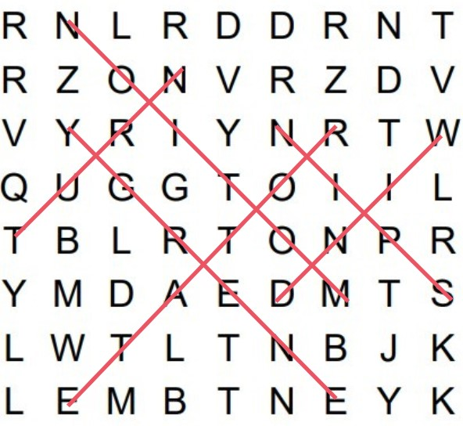
Q: Write 2 sentences explaining the rotor’s role in energy conversion (use at least 4 vocab words from the puzzle).
Look for: kinetic → mechanical energy, mention shaft, wind, motion, rotation, torque, etc.
Sample Answer (with underlined words):
The rotor captures wind and turns it into motion. This rotation creates torque that spins the shaft to start making energy. Final Check
- All 5 cards earned: Each station completed with acceptable answers.
- Bonus card earned: Either correct Rotor motion demo or strong answer at Blades Station.
- Final Destination Build:
  - All 5 parts drawn and labeled.
  - Creative turbine name.
  - Color and detail.
  - Explanation of performance in Kansas winds.
Sample Answer for Build Explanation:
Our turbine ‘Kansas Twister’ has a wide base and tall tower. It would work well in Kansas because it is built to handle strong winds and still generate electricity safely.
Cards and Station Labels


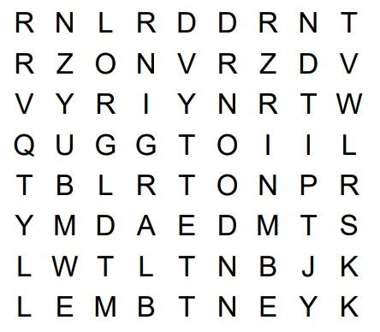
Rotor Word Search

Spin Turn Rotate

Motion Energy Wind

