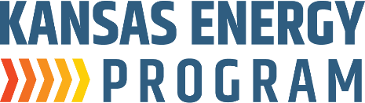
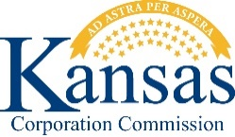

Sponsored by the K-State Engineering Extension’s Kansas Energy Program and the Kansas Corporation Commission:

K-12 Energy Benchmarking Project Workshop

Organizers/Speakers from the Kansas Energy Program:
- David Carter
- Kurt Foley
- Ryan Hamel
- Mandy Putnam
- Stacy Harris

When: Wednesday, September 24th, 9:00am – 4:00pm (6 hours)

Where: K-State Innovation Center
2005 Research Park Circle
Manhattan, KS 66502

Cost: Free

Continuing Professional Competency Activity Attendance Verification

The workshop presented as part of the K-12 Energy Benchmarking Project is intended to provide the number of contact hours shown above and the opportunity for you to earn the equivalent number of Professional Development credit hours. It is your responsibility to certify the time you actually spent in attendance and the applicability of the content to your field of practice.

I certify that I spent hours in attendance of the above program, and I further certify that the presented material assisted me in maintaining, improving, or expanding the skills and knowledge related to my field of practice.

Participant Name: ___________________________________________________________ ^{(Print)}

__________________________________________________________________________
^{(Signature)}

Attendance verified by: f
^{(Signature)}

