Energy Word Combinations (solution)

Form six 9-letter words by combining two of the twelve 3-letter block
combinations shown below (right) with each beginning in the grid. All blocks
will be used. If you do it correctly, one of the vertical columns will spell a
common English word describing a person using sound energy.
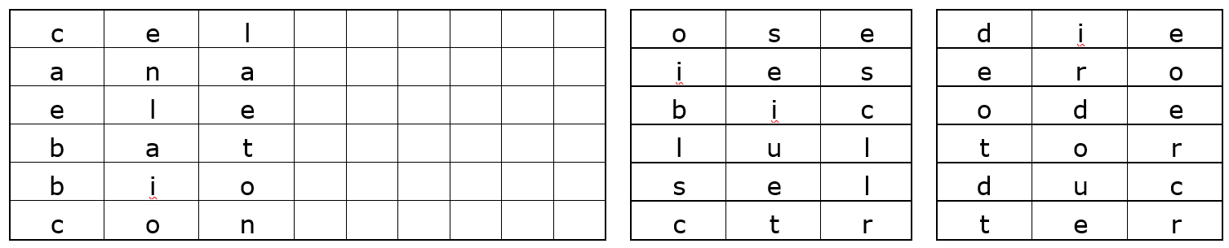
Key:
c | e | l | l | u | l | o | s | e
a | n | a | e | r | o | b | i | c
e | l | e | c | t | r | o | d | e
b | a | t | t | e | r | i | e | s
b | i | o | d | i | e | s | e | l
c | o | n | d | u | c | t | o | r

Form six 9-letter words by combining two of the twelve 3-letter block
combinations shown below (right) with each 3-letter block in middle of the grid.
All blocks will be used. If you do it correctly, one of the vertical columns will
spell a common English word describing what teenagers usually make. 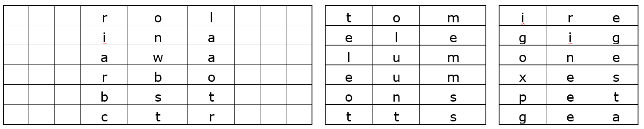
p | e | t | r | o | l | e | u | m
l | u | m | i | n | a | i | r | e
g | i | g | a | w | a | t | t | s
g | e | a | r | b | o | x | e | s
t | o | m | b | s | t | o | n | e
e | l | e | c | t | r | o | n | s

Form six 9-letter words by combining two of the twelve 3-letter block combinations
shown below (right) with each beginning in the grid. All blocks will be used. If you
do it correctly, one of the vertical columns will spell a common English word
describing a person who might make you feel better.
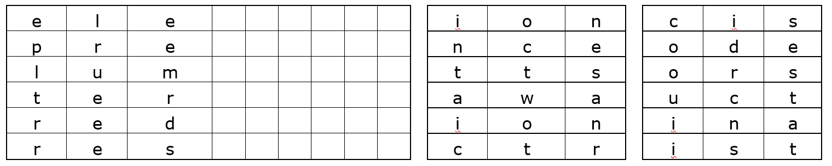
e | l | e | c | t | r | o | d | e
p | r | e | c | i | s | i | o | n
l | u | m | i | n | a | n | c | e
t | e | r | a | w | a | t | t | s
r | e | d | u | c | t | i | o | n
r | e | s | i | s | t | o | r | s

