Sustainability Word Scramble (solution)

Unscramble the letters in the circle to make words using the clues next to the blank.

1. State of being unlikely to change: __ __ __ __ __ __ __ __ __
2. Prohibit: __ __ __ unsustainable practices
3. Appropriate for a specific purpose: __ __ __ __ __ __ __ __ __ __ __
4. Refuse to participate. For example: __ __ __ __ __ __ __ from environmental
degradation
5. Scientific study: __ __ __ __ __ __ __ __
6. Current level is able to be maintained: __ __ __ __ __ __ __ __ __ __ __ __
__ __
7. __ __ __ __ __ __ __ cost of installation may be higher, but using renewable
energy sources can save money long-term
8. Large quantity, important: __ __ __ __ __ __ __ __ __ __ __
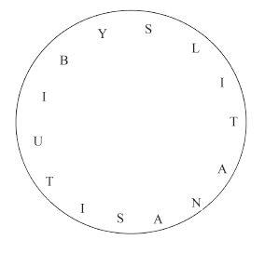
- Stability
- Ban
- Suitability
- Abstain
- Analysis
- Sustainability
- Initial
- Substantial

