Energy Audit Equipment
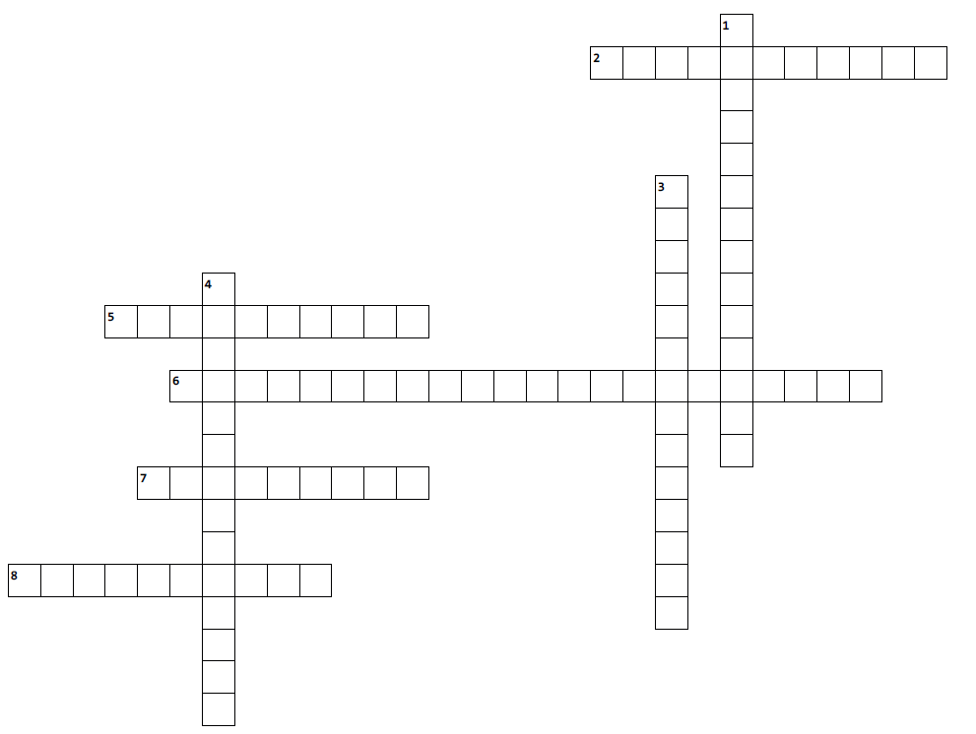
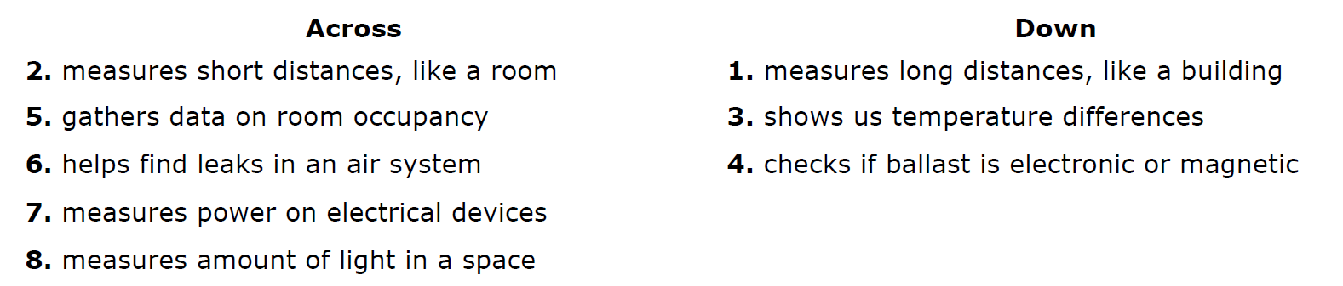
Hint: All answers are at least 2 words, no space

