How to Choose a Lightbulb
To be used in conjunction with the “How to Choose an LED Lightbulb Factsheet.”

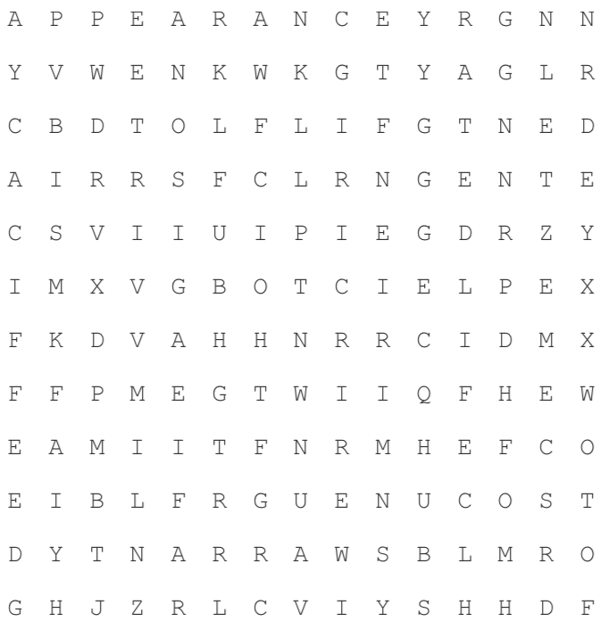

APPEARANCE | BRIGHTNESS | COST
DIMMABILITY | EFFICACY | LIGHTING
LUMINOUS | RATEDLIFE | RENDERING
WARRANTY

